**同步练习6-1(2)**

**源代码**

1. #include <iostream>
2. **using** **namespace** std;
4. **class** student
5. {
6. **public**:
7. student():id(0),score(0)    //初始化
8. {
9. name[**sizeof**(name)-1]='\0';
10. }
11. **void** input(student &stu);
12. **void** output(student &stu);
13. **private**:
14. **char** name[20];
15. unsigned **int** id;
16. **double** score;
17. };
19. **void** student::input(student &stu)   //数据输入
20. {
21. cout<<"Name?";
22. cin>>stu.name;
23. cout<<"ID?";
24. cin>>stu.id;
25. cout<<"Score?";
26. cin>>stu.score;
27. }
29. **void** student::output(student &stu)
30. {
31. cout<<"Name: "<<stu.name
32. <<"\tID: "<<stu.id
33. <<"\tScore: "<<stu.score<<endl;
34. }
36. **int** main()
37. {
38. student s;
39. s.input(s);
40. s.output(s);
42. cin.get();
43. cin.get();
44. }

**运行截图**

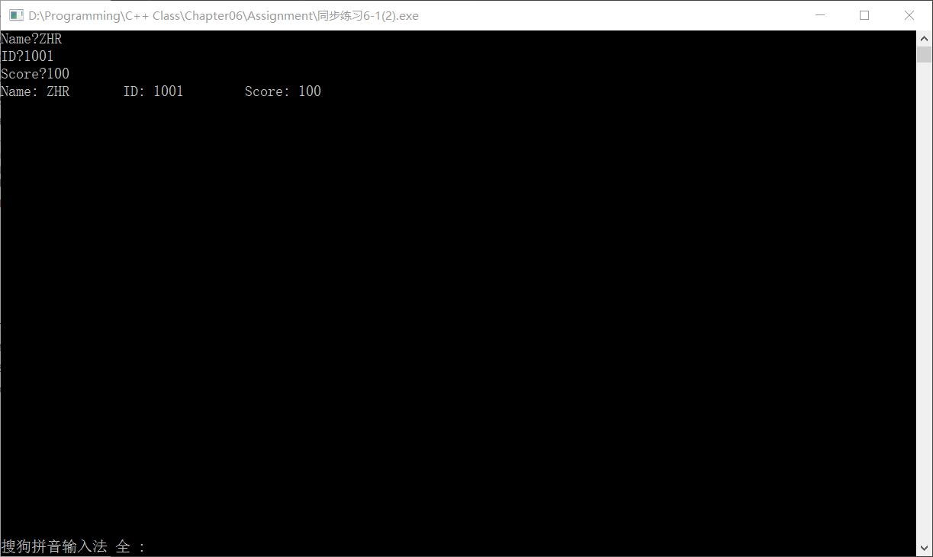

**综合练习(1)**

**源代码**

1. #include <iostream>
2. #include <cstring>
3. **using** **namespace** std;
5. **class** Book
6. {
7. **public**:
8. Book(**char** *pbookname,**double** p,**int** n);
9. **void** display();     //显示图书情况
10. **void** borrow();      //借书
11. **void** restore();     //还书
13. **private**:
14. **char** *bookname;
15. **double** price;
16. **static** **int** number;      //静态存储总数number
17. };
18. **int** Book::number=0;
20. Book::Book(**char** *pbookname,**double** p,**int** n)  //新建对象时可对其中数据初始化
21. {
22. bookname=**new** **char**[strlen(pbookname)+1];
23. strcpy(bookname,pbookname);     //老师，我用的IDE不是VS，所以库里面没有strcpy_s，小程序用strcpy应该没有什么影响吧
24. price=p;
25. number=n;
26. }
28. **void** Book::display()
29. {
30. cout<<"Name: "<<bookname
31. <<"\tPrice: "<<price
32. <<"\tThe number of "<<bookname<<": "<<number<<endl;
33. }
35. **void** Book::borrow()
36. {
37. **if**(number)      //注意到没书可借的情况
38. {
39. number--;
40. cout<<"The number of "<<bookname<<": "<<number<<endl;
41. }
42. **else**
43. cout<<"Sorry, we got nothing left!"<<endl;
44. }
46. **void** Book::restore()
47. {
48. number++;
49. cout<<"The number of "<<bookname<<": "<<number<<endl;
50. }
52. **int** main()
53. {
54. Book Harry_Potter("Harry Potter",20.16,3);
55. Harry_Potter.display();
57. **int** choice;
59. **do**
60. {
61. cout<<"You wanna?\t1-Borrow\t2-Return\t0-Quit"<<endl;
62. cin>>choice;
63. **switch**(choice)
64. {
65. **case** 1:
66. {
67. Harry_Potter.borrow();
68. **break**;
69. }
70. **case** 2:
71. {
72. Harry_Potter.restore();
73. **break**;
74. }
75. **case** 0:
76. { **break**; }
77. }
78. }**while**(choice);
80. cin.get();
81. cin.get();
82. }

**运行截图**

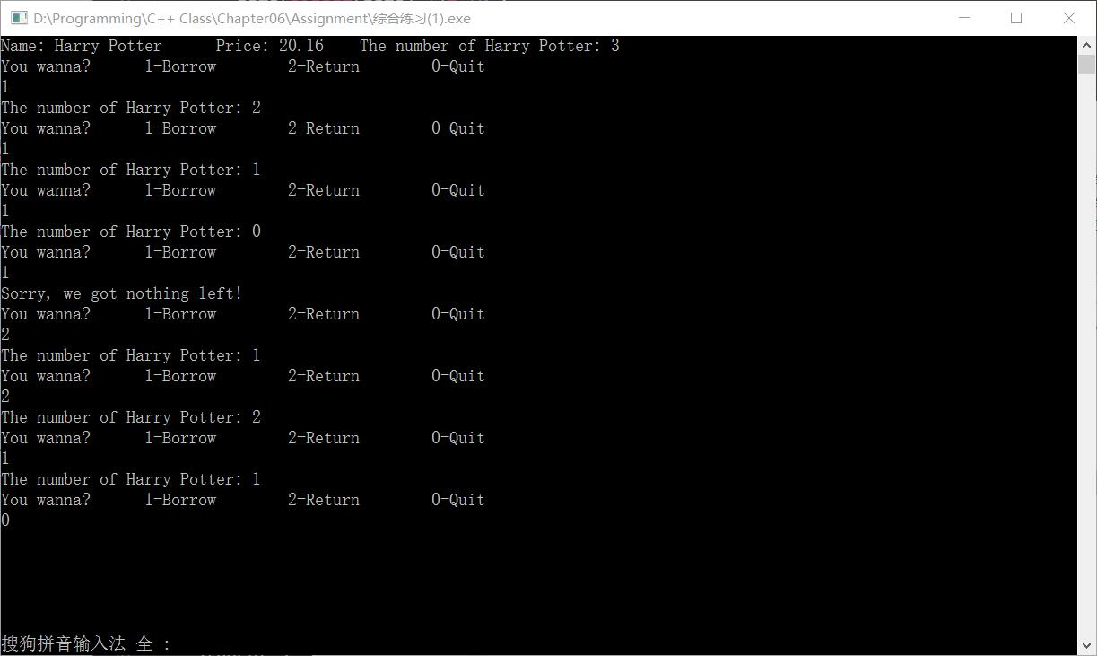

**综合练习(3)**

**源代码**

1. #include <iostream>
2. **using** **namespace** std;
4. **class** Student
5. {
6. **public**:
7. **void** scoretotalcount(**double** s);   //设置分数、求总分、累计学生人数 不明白干嘛不用构造函数= =
8. **static** **double** sum();    //返回总分
9. **static** **double** average();    //求平均值
10. **private**:
11. **double** score;   //个人分数
12. **static** **int** count;   //学生总人数
13. **static** **double** total;    //学生总分
14. };
15. **int** Student::count=0;
16. **double** Student::total=0;
18. **void** Student::scoretotalcount(**double** s)
19. {
20. score=s;
21. total+=s;
22. count++;
23. }
24. **double** Student::sum()
25. {
26. **return** total;
27. }
29. **double** Student::average()
30. {
31. **return** total/**double**(count);
32. }
34. **int** main()
35. {
36. **int** i=1,choice;
37. **double** s;
38. Student *p=NULL;    //做一下保护
40. **do**
41. {
42. cout<<"You wanna:\t1-Input Student"<<i<<"'s score\t0-Quit\t";
43. cin>>choice;
45. **switch**(choice)
46. {
47. **case** 1:
48. {
49. cout<<"Please input Student"<<i<<"'s score:";
50. cin>>s;
51. p=**new** Student;
52. p->scoretotalcount(s);       //新建动态的对象，修改static数值
53. **break**;
54. }
55. **case** 0:
56. { **break**; }
57. }
59. i++;
60. **if** (p!=NULL)
61. {
62. **delete** p;   //留下static数据即可，其他清除（这个类里的score好像对这个程序的目的没什么用）
63. p=NULL;     //保护
64. }
66. }**while**(choice);
68. cout<<"The total score:"<<Student::sum()<<'\t'
69. <<"The average score:"<<Student::average()<<endl;
71. cin.get();
72. cin.get();
73. }

**运行截图**

